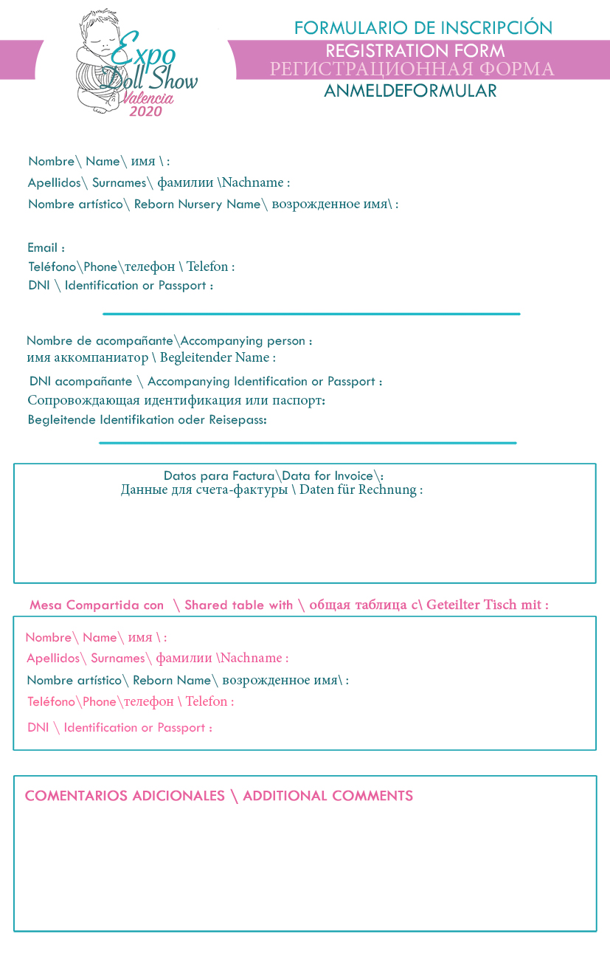

EXAMPLE

EXAMPLE

EXAMPLE

EXAMPLE

EXAMPLE

EXAMPLE

EXAMPLE

EXAMPLE

EXAMPLE

EXAMPLE

EXAMPLE

EXAMPLE

EXAMPLE

EXAMPLE

EXAMPLE

EXAMPLE

EXAMPLE

EXAMPLE